APPENDICES
Appendix 1. Stock returns of studied markets
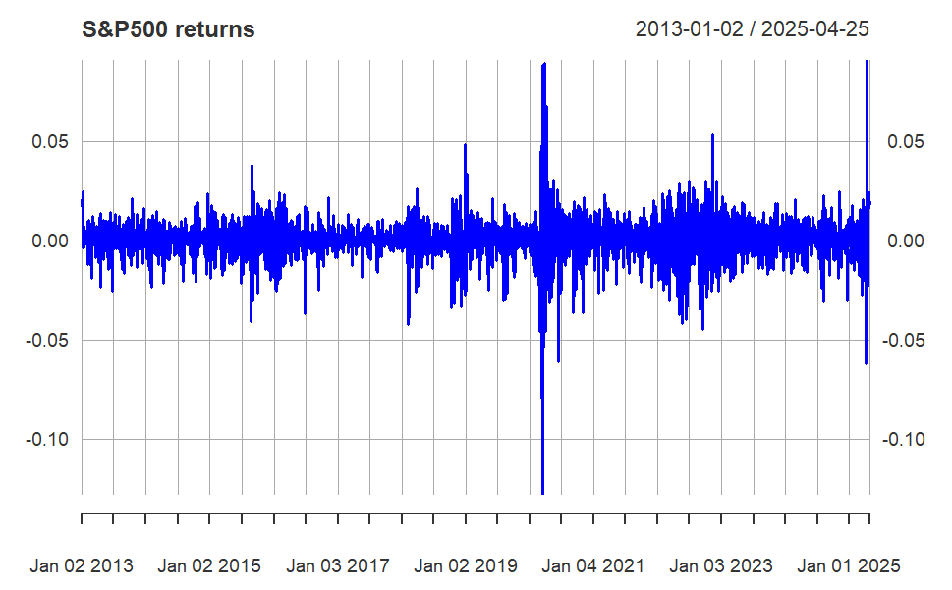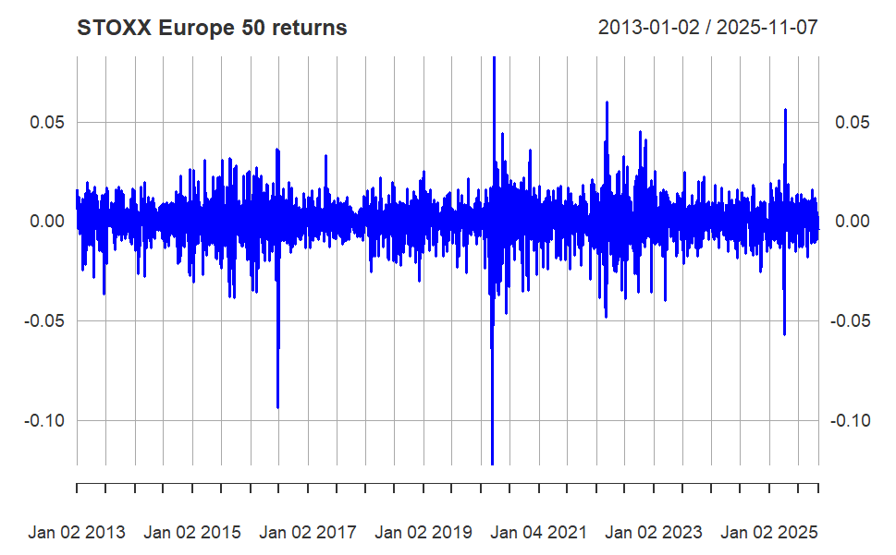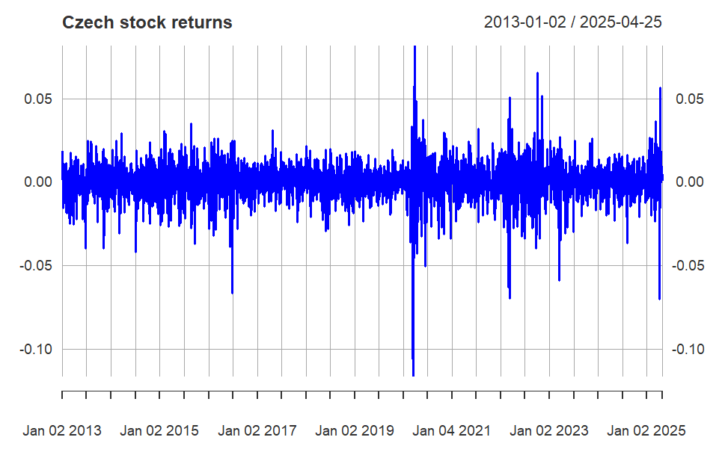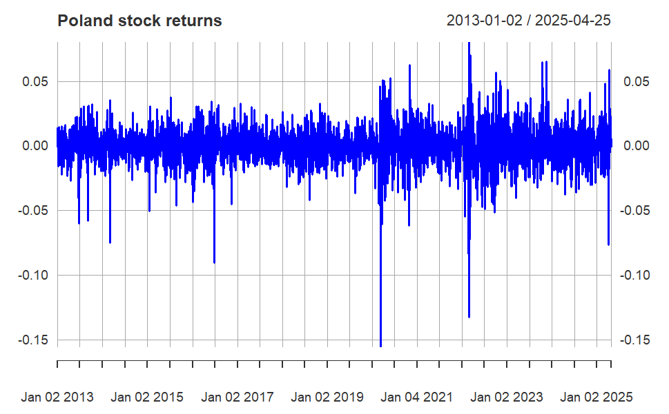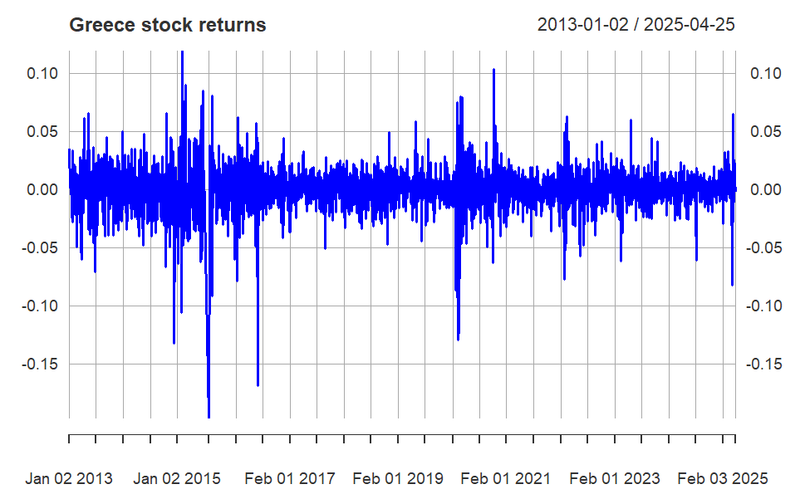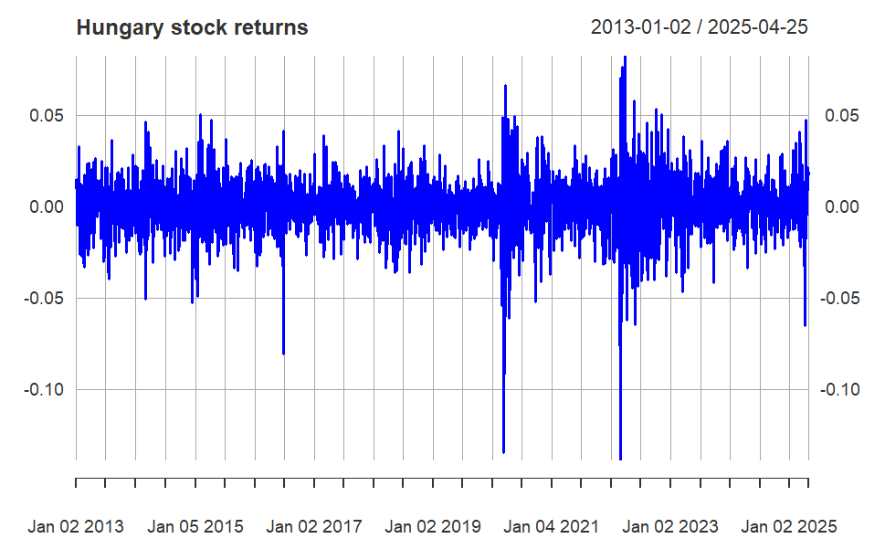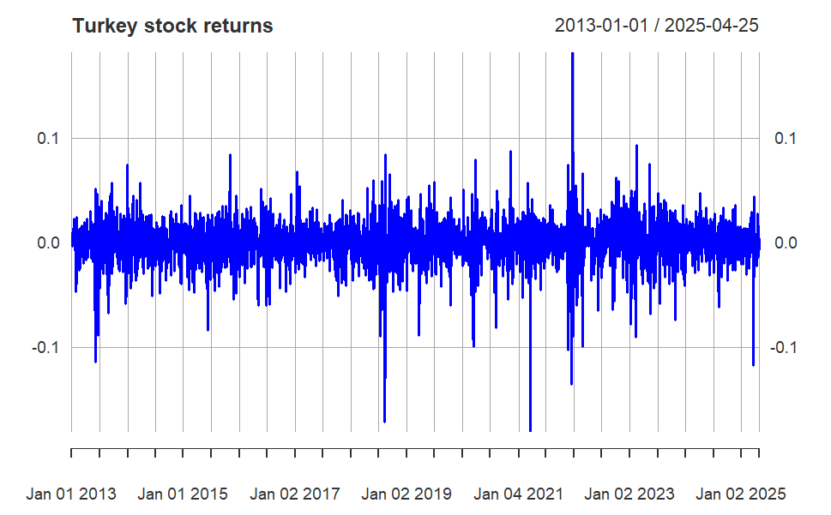
Appendix 2. Details on the Bayesian inference framework in Eq. A(1)
Eq. A(1) can be rewritten in matrix notation:
$$R_{i}=G_{i}θ_{i}+e_{i}$$
where $R_{i}$is the vector of returns of individual emerging markets. Parameters $β_{0,i}; β_{t,i}^{US}; β_{t,i}^{EU}$I are attached to vector $θ_{i}$ and $G_{i}=\left[r_{t-1}^{US} r_{t}^{EU}\right]$
Prior function
$$p\left(\left(θ_{i} | G_{i}\right)\right)$$
The prior function, $p\left(\left(θ_{i} | G_{i}\right)\right)$, is a probability distribution that describes our uncertainty about the parameters θ before observing the data R. Typically we have at least a minimal level of prior information. Denote µθ and Vθ as the vector of prior means and the covariance matrix of model parameters. A prior distribution for the parameters $θ_{i,0}$ is given as follows:
$$θ_{i,0}\sim Ν (μ_{θ},V_{μ_{θ}})$$
where $μ_{θ}$ is the zero vector and the scale of the priors on the coefficients (standard deviation) is 2.5 (Muth, Oravecz, & Gabry, 2018).
Likelihood function
$$p\left(R_{i} | θ_{i},G_{i}\right)∝\prod_{i=1}^{N}{\frac{1}{σ_{ξ_{i}}^{T}}exp\left(-\frac{1}{2σ_{ξ_{i}}^{2}}\right){\left(R_{i}-G_{i,0}θ_{i,0}\right)}^{'}\left(R_{i}-G_{i,0}θ_{i,0}\right)⁡}$$
The likelihood is the joint probability of the data $R_{i}$ for all possible values of the parameters θ, given the observed predictors $G_{i}$.
Posterior distribution
The posterior$p(\left(θ_{i} | R_{i},G_{i}\right)$, is the joint probability distribution of all parameters θ reflecting our updated knowledge about the parameters after we have observed $R_{i}$. According to Bayes’ theorem:
$p(\left(θ_{i} | R_{i},G_{i}\right)∝p\left(R_{i} | θ_{i},G_{i}\right)p\left(\left(θ | G_{i}\right)\right)$; where ∝ indicates proportionality.
To explore the shape of the desired posterior distribution, the Hamiltonian Monte Carlo algorithm within the Gibbs procedure is implemented.

References

Muth, C., Oravecz, Z., and Gabry, J. (2018). User-friendly Bayesian regression modeling: A tutorial with rstanarm and shinystan. The Quantitative Methods for Psychology, 14(2), 99-119. doi: 10.20982/tqmp.14.2.p099.

