Title: Xxxxxxxxxxxxxxxx xxxxx xxxxx

Author A. First name + Family Name^{1, *}, Author B. First name + Family name², Author C. First name + Family name³
¹ Affiliation (i) University/Institution, (ii) Faculty/Department, (iii) Country, (iv) ORCID, (v) Email.
² Affiliation (i) University/Institution, (ii) Faculty/Department, (iii) Country, (iv) ORCID, (v) Email.
³ Affiliation (i) University/Institution, (ii) Faculty/Department, (iii) Country, (iv) ORCID, (v) Email.
* Corresponding author. Email: xxxxx@xxxx.xxx

ABSTRACT:

KEYWORDS: keyword 1, keyword 2, keyword 3, keyword 4, keyword 5, keyword 6

INTRODUCTION
Xxxxxxxxx xxxxx xxxxxxxx (Liu et al., 2020). Xxxxxxxx xxxxxx xxxxxxxx (Ziółkowski et al., 2024). Xxxxxxxxx xxxxxxx, xxxxxx xxxxxx (Streeck, 2023a, 2023b). Xxxxxxx xxxxxx (Kopnina et al., 2022). Xxxxxx xxxxxx xxxxxxxx, xxxxxxx x xxxxxxxxxx. Xxxxxx xxxxxx xxxxxxxx, xxxxxxx x xxxxxxxxxx.
CONCEPTUALIZING SCIENCE POLARIZATION
Xxxxxx xxxxxx xxxxxxxx, xxxxxxx x xxxxxxxxxx (Thompson, 2022). Xxxxxx xxxxxx xxxxxxxx, xxxxxxx x xxxxxxxxxx. Xxxxxx xxxxxx xxxxxxxx, xxxxxxx x xxxxxxxxxx. Xxxxxx xxxxxx xxxxxxxx, xxxxxxx x xxxxxxxxxx. Xxxxxx xxxxxx xxxxxxxx, xxxxxxx x xxxxxxxxxx (Davidson, 2019). Xxxxxx xxxxxx xxxxxxxx, xxxxxxx x xxxxxxxxxx (Thompson, 2022). Xxxxxx xxxxxx xxxxxxxx, xxxxxxx x xxxxxxxxxx. Xxxxxx xxxxxx xxxxxxxx, xxxxxxx x xxxxxxxxxx. Xxxxxx xxxxxx xxxxxxxx, xxxxxxx x xxxxxxxxxx. Xxxxxx xxxxxx xxxxxxxx, xxxxxxx x xxxxxxxxxx (Davidson, 2019).
CONCLUSIONS
Xxxxxx xxxxxx xxxxxxxx, xxxxxxx x xxxxxxxxxx (Thompson, 2022). Xxxxxx xxxxxx xxxxxxxx, xxxxxxx x xxxxxxxxxx. Xxxxxx xxxxxx xxxxxxxx, xxxxxxx x xxxxxxxxxx. Xxxxxx xxxxxx xxxxxxxx, xxxxxxx x xxxxxxxxxx. Xxxxxx xxxxxx xxxxxxxx, xxxxxxx x xxxxxxxxxx (Davidson, 2019). Xxxxxx xxxxxx xxxxxxxx, xxxxxxx x xxxxxxxxxx (Thompson, 2022). Xxxxxx xxxxxx xxxxxxxx, xxxxxxx x xxxxxxxxxx. Xxxxxx xxxxxx xxxxxxxx, xxxxxxx x xxxxxxxxxx. Xxxxxx xxxxxx xxxxxxxx, xxxxxxx x xxxxxxxxxx. Xxxxxx xxxxxx xxxxxxxx, xxxxxxx x xxxxxxxxxx (Davidson, 2019).

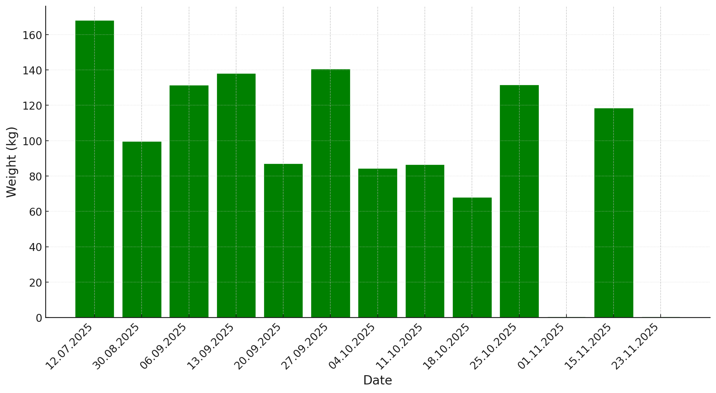
Fig. 1. Measurement of recovered food
Source: Authors’ own elaboration

REFERENCES (APA 7)
Davidson, R. J. (2019, August 8–11). Well-being is a skill [Conference session]. APA 2019 Convention, Chicago, IL, United States. https://irp-cdn.multiscreensite.com/a5ea5d51/files/uploaded/APA2019_ Program_190708.pdf
Kopnina, H., Boatta, F., Baranowski, M., & de Graad, F. (2022). Does waste equal food?: Examining the feasibility of circular economy in the food industry. In H. Lehmann, C. Hinske, V. de Margerie, & A. S. Nikolova (Eds.), The impossibilities of the circular economy: Separating Aspirations from Reality (pp. 11–22). Routledge.
Liu, Z., Ciais, P., Deng, Z., Lei, R., Davis, S. J., Feng, S., Zheng, B., Cui, D., Dou, X., Zhu, B., Guo, Rui, Ke, P., Sun, T., Lu, C., He, P., Wang, Yuan, Yue, X., Wang, Yilong, Lei, Y., … Schellnhuber, H. J. (2020). Near-real-time monitoring of global CO2 emissions reveals the effects of the COVID-19 pandemic. Nature Communications, 11(1), 5172. https://doi.org/10.1038/s41467-020-18922-7
Streeck, W. (2023a). Reflections on the particular and the universal: Unity and diversity in social life and social theory. Society Register, 7(2), 7–20. https://doi.org/10.14746/sr.2023.7.2.01
Streeck, W. (2023b). Rejoinder to Crouch. Journal of Classical Sociology, 23(3), 452–459. https://doi.org/10.1177/1468795X231187110
Thomson, J. (2022, September 8). Massive, strange white structures appear on Utah’s Great Salt Lake. Newsweek. https://www.newsweek.com/mysterious-mounds-great-salt-lake-utah-explainedmirabilite-1741151
Ziółkowski, M., Drozdowski, R., & Baranowski, M. (2024). A Sociological Approach to Commodification: The Case of Transforming the Post-Socialist Society in Poland. Routledge.

Funding: Add funding information with grant numbers, funding agency names, and recipient’s names and surnames.
Acknowledgments:
Author contributions:
Conceptualization: XXX, XXX
Methodology: XXX, XXX
Investigation: XXX, XXX
Visualization: XXX, XXX
Funding acquisition: XXX, XXX
Project administration: XXX, XXX
Supervision: XXX
Writing – original draft: XXX, XXX
Writing – review & editing: XXX, XXX

